VBA Homework – The VBA of Wall Street

# Multi-Year Stock Data -Screenshots

## 2014

## 2015

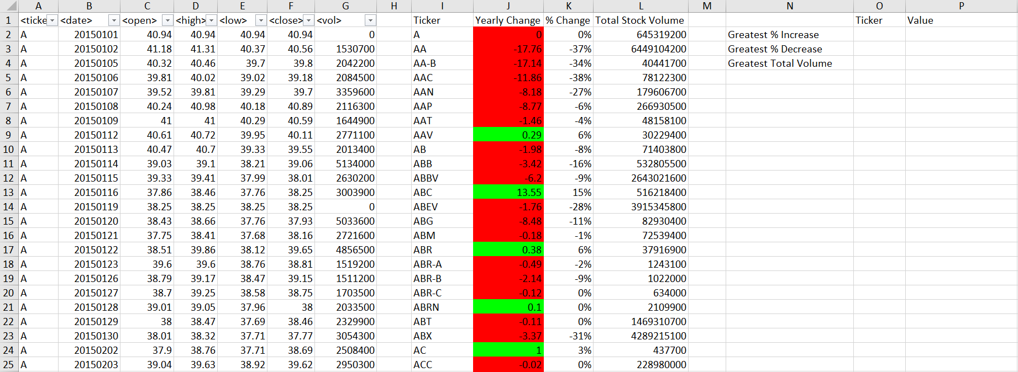

## 2016

